Project Design Phase-II
Data Flow Diagram & User Stories

Date | 09 February 2026
Team ID | LTVIP2026TMIDS86901
Project Name | ToyCraft Tales: Tableau's Vision into Toy Manufacturer Data
Maximum Marks | 4 Marks

Data Flow Diagrams:
A Data Flow Diagram (DFD) is a traditional visual representation of the information flows within a system. A neat and clear DFD can depict the right amount of the system requirement graphically. It shows how data enters and leaves the system, what changes the information, and where data is stored.
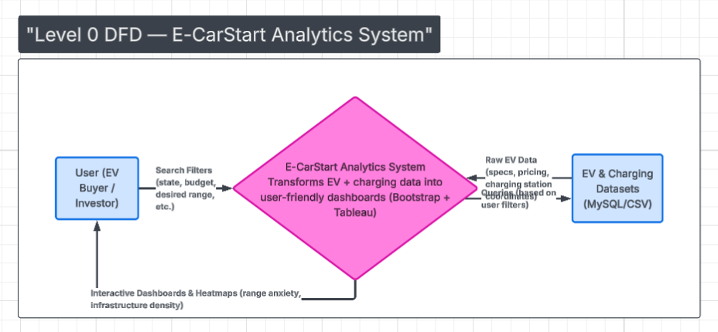
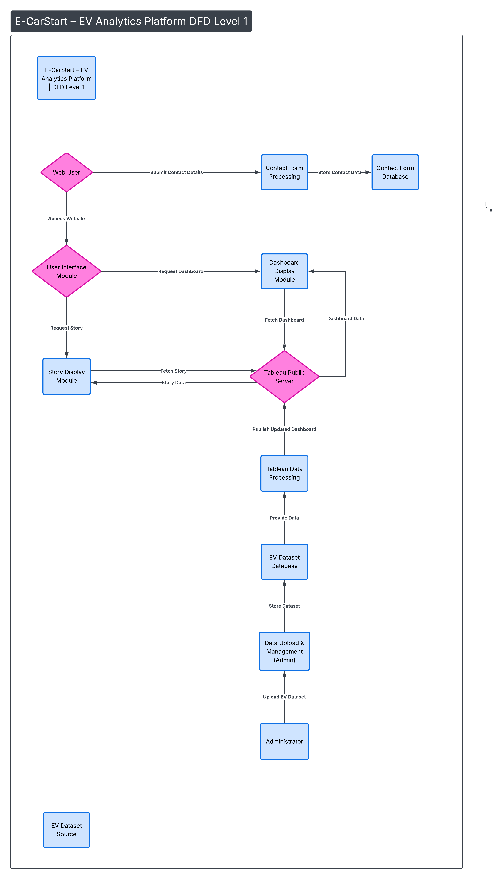

User Stories
Use the below template to list all the user stories for the product.
User Type | Functional Requirement (Epic) | User Story Number | User Story / Task | Acceptance criteria | Priority | Release
Customer (Web user) | Website Access | USN-1 | As a user, I can access the E-CarStart website from any browser. | Website loads without errors | High | Sprint-1
Customer (Web user) | View Dashboard | USN-2 | As a user, I can view the EV Charging & Range Dashboard. | Dashboard loads successfully | High | Sprint-1
Customer (Web user) | View Story | USN-3 | As a user, I can explore the EV Analytics Story. | Story loads and tabs function correctly | High | Sprint-1
Customer (Web user) | Navigation | USN-4 | As a user, I can navigate between Home, About, Dashboard, Story, Team & Contact sections. | Navigation links scroll properly | High | Sprint-1
Customer (Web user) | Contact Form | USN-5 | As a user, I can submit my details through the contact form. | Form validates required fields | High | Sprint-1
Customer (Web user) | Responsive Design | USN-6 | As a user, I can access the website on mobile and desktop. | Layout adjusts responsively | Medium | Sprint-2
Administrator | Data Upload | USN-7 | As an admin, I can upload EV dataset to Tableau. | Dataset uploads successfully | High | Sprint-1
Administrator | Dashboard Update | USN-8 | As an admin, I can update dashboard visuals. | Updated dashboard reflects changes | High | Sprint-1
Administrator | Publish Dashboard | USN-9 | As an admin, I can publish dashboard to Tableau Public. | Dashboard embed works on website | High | Sprint-1

